# LAB 4 - Selection

**30 Points**

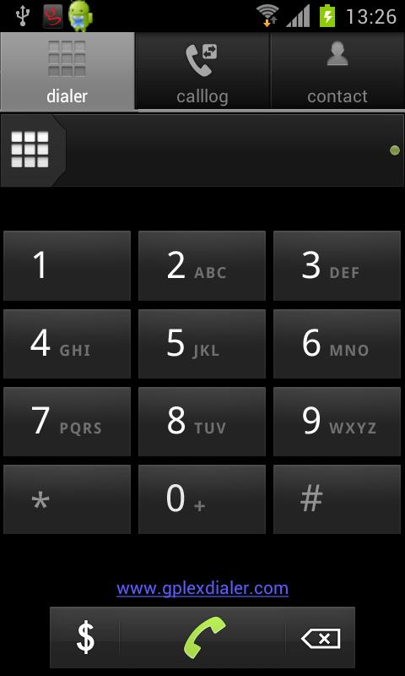Develop an algorithm for a Java program that takes as input a single letter and displays the corresponding digit on the telephone. The letters and digits on a telephone are grouped this way:

2 = ABC 3 = DEF 4 = GHI 5 = JKL

6 = MNO 7 = PQRS 8 = TUV 9 = WXYZ

The screen dialog might look like this:

**Enter a single letter, and I will tell you what the corresponding digit is on the telephone.**

**R**

**The digit 7 corresponds to the letter R on the telephone.**

The program should display a message indicating that there is no matching digit for any non-alphabetic character entered by the user. Also, the application should recognize only uppercase letters. If a user enters a lowercase letter, the program should display an error message.Prompt the user with an informative message for the input value as shown above.

The application should include the input letter as part of the output.

**Write the algorithm to solve this problem including steps for prompting the user, getting input from the keyboard, and displaying the results.**

**Generate test cases as part of a Test Plan to exercise all branches of your program.** Follow the guidelines on pages 108-9 of the textbook, Big Java, and provide *complete coverage* of all decision points. Use the Test Plan document to list all of your test data and the expected results.

**Write the Java program that you designed, using your algorithm as a guide. Use your algorithm as comments in the body of the main method.**

Use proper indentation, and meaningful identifiers throughout the code. **Run each of the test cases that you created and record the results on the testing document. Upload both the source code and your completed test cases to the assignment link in Blackboard.**